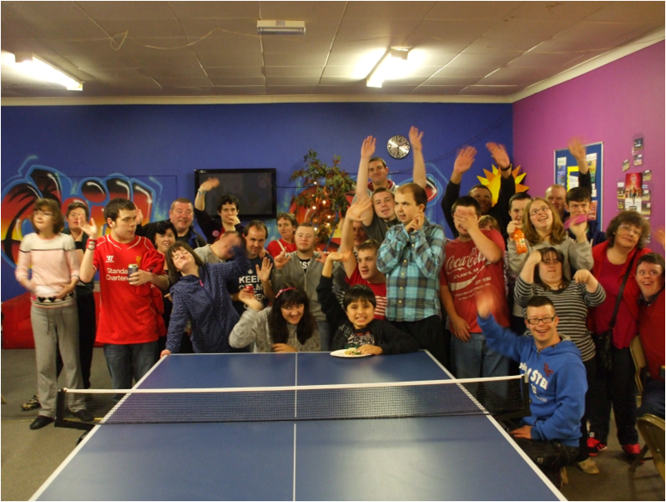  Summer Term 2017 |  | Ty Celyn  - Sunday Club

Welcome back after the Easter break
Last term at club we had some very enjoyable events, in particular the Cardiff Sub Aqua group who came along and let us try on their gear; the fashion show held by The Copper Tree which raised over £1000 for club and our Easter egg Hunt! Thank you to everyone who joined us.

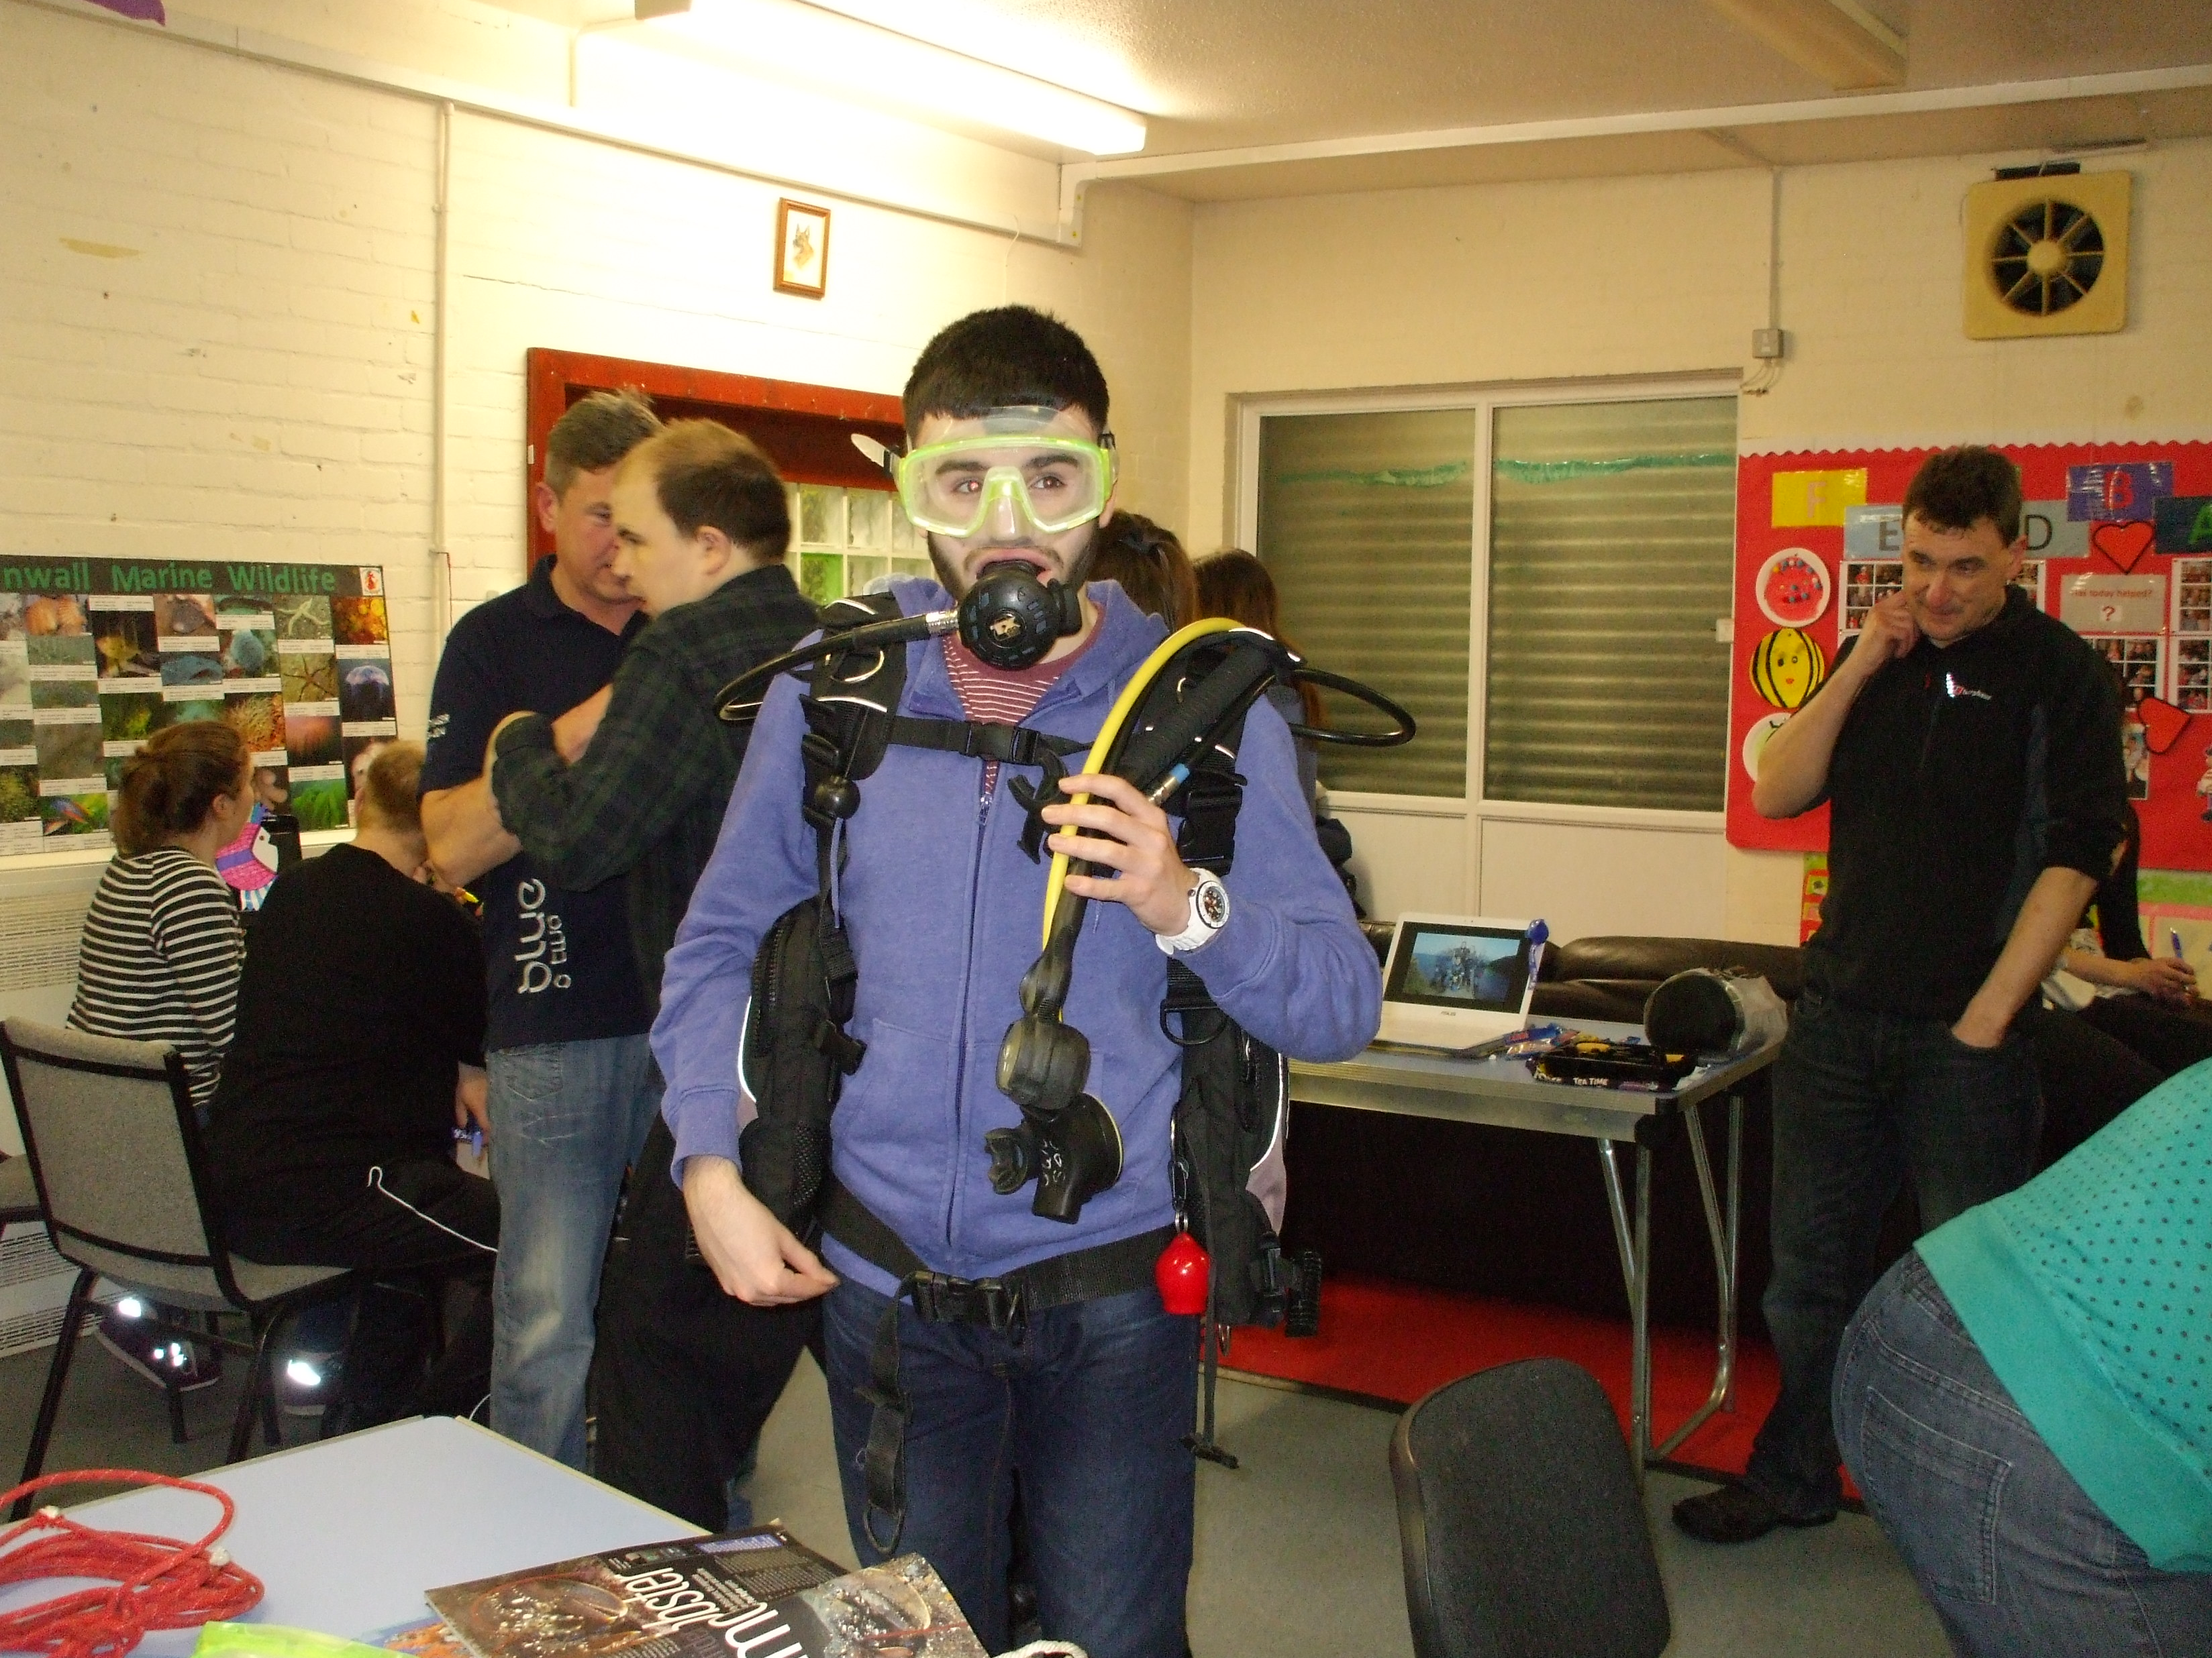

This summer we have lots of fundraising activities / events. Please come along to as many as possible and where appropriate bring family and friends. All events will be published both on our website and on the club Facebook page. Club can only continue to function if we all make an effort to support the fundraising activities. If you have any fundraising ideas or wish to be involved with fundraising please speak to Anna or Charlie.

Mention fashion show

Club dates

Summer term dates: 23rd April – 16th July
(no club– 28th May as half term & no club on bank holiday weekends)

Dates for Your Diary
21st May 2017 South Wales Classic Car Show
The SWCC club is having their classic car show at Cardiff City Football Stadium.
We have been fortunate to benefit from regular donations from the Classic Car Club so please come along and show your support.
28th May 2017 Edinburgh Marathon
Steve Davies is running his first ever marathon to raise money for club! He has a Just Giving Page (just search Ty Celyn Sunday Club) which you are welcome to donate to and share the page with friends and family.
3rd June 2017 Swishing Party
We are holding a swishing party at Roath Scouts Hall on Saturday 3rd June, doors open at 2pm (see box opposite).
14th June 2017 Pub Quiz
There will be a pub quiz at the Butchers Pub in Rhiwbina at 8pm (time to be confirmed). It is also steak night (steak and a drink for £10.95).
16th July 2017 End of Term Party
We will be having our end of term party on 16th July – details to be confirmed!

Swishing Party
(doors open at 2pm, donation drop off from 1:30pm)
- Bring your unwanted clothes, shoes, accessories
- Get 1 ticket per item
- Browse the other items available
- When the till opens you can purchase items at 1 ticket = 1 item (any other items are £1 each)
- Free admission but a donation to club is very welcome
- We will have homemade cakes and refreshments available
Steve Davies has wanted to run a marathon for over 30 years. He has decided that 2017 is the year for running and will be taking part in the Edinburgh marathon on 28th May! He has very kindly chosen to raise money for Sunday club with his marathon run which to date has received over £650 of donations. To donate please go to https://www.justgiving.com/fundraising/Steve-Davies38 or to donate in person please see Anna or Maggie.
We wish Steve all the luck for his marathon and look forward to seeing the finishing photos.
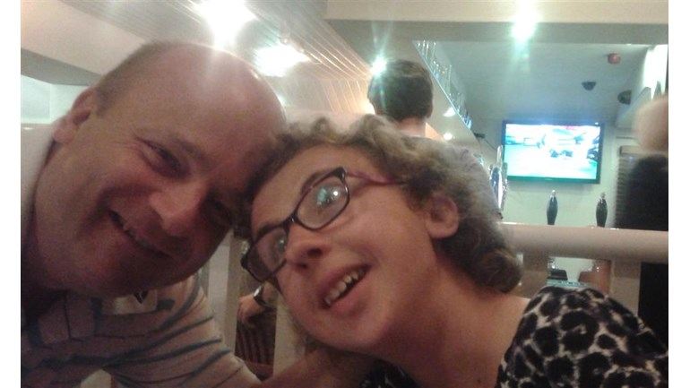

As you may be aware we have a club website www.tycelynsundayclub.org. Please keep an eye on the website as it will have all the information you need about club dates, fundraising events as well as publishing the photos we take at club. We also have a dedicated email address for club sundaycirclecardiff@gmail.com

