|  |  |  |  |  |
| --- | --- | --- | --- | --- |
| C:\Users\annan_000\Pictures\Ty Celyn Thank You.png  **Spring Term 2018** |  | |  | | --- | | Sunday Circle | |  | |
|  |  |  |
|  |  |  |

**Welcome back!**

Hope you all had a good Christmas and New Year and are looking forward to a fun-filled spring term ☺

Last term we had some fantastic trips and activities including a trip to the Pantomime; visit from the SubAqua club; music from the Ukulele Wolves; a Pub Quiz and our Christmas Fayre.

 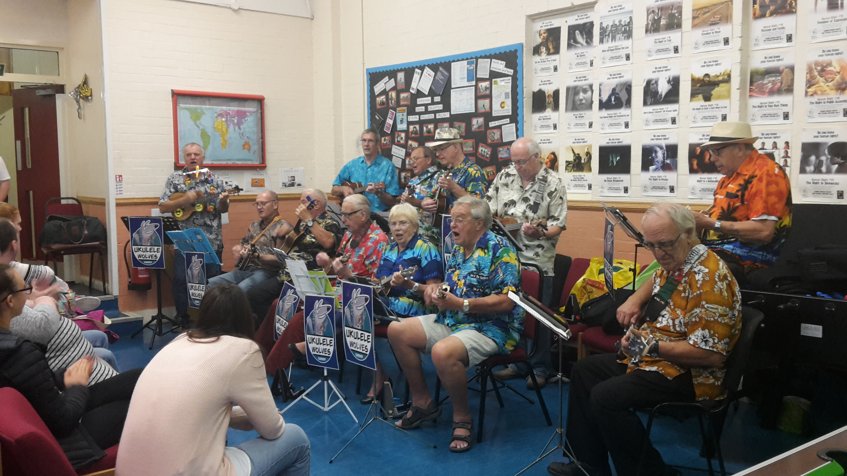 

The Christmas Fayre raised a fantastic £450 for club. Thank you to everyone who came to support us and I hope you got some great Christmas gifts. We also raised £50 from our Pub Quiz – congratulations to Daniel Hughes and family who won a voucher for The Butchers Pub.

Hopefully we will have lots of fundraising activities this coming year for you to get involved with. If you have any opportunities to help us raise funds for club please let us know.

Mention fashion show

**Club dates**

**Spring term dates: 7th January – 18th March**

**(no club 18th Feb – half term)**

We were unsuccessful with our application for the Aviva Fund however they are donating £100to us at club. Thanks to everyone who voted for us.

|  |
| --- |
|  |
| Giant congratulations to our sports team who won the Welsh Sports Competition. Fantastic achievement and well done to everyone who took part.  C:\Users\annan_000\AppData\Local\Microsoft\Windows\INetCache\IE\Z22HSEK2\premio[1].jpg |

Well done to everyone who helped us raise money for MacMillan Cancer Care.



**Member Achievements**

We are going to start a section on our website celebrating our member’s achievements. This could be anything from a personal achievement to a sporting one, winning the local bingo or even meeting a celebrity.

 

If you would like to nominate a member for their achievement please do so by emailing [sundaycirclecardiff@gmail.com](mailto:sundaycirclecardiff@gmail.com) Send a photo, along with a brief description and we will get it up on our website as soon as we can.

Please don’t forget to visit our website (currently being updated) for lists of all our upcoming events and stories.

This term at club we will be having a fire drill. Cardiff City Council (who owns the building) will be testing the fire alarms on various days/times. They are hoping to wait a little bit until the evening light improves so help minimise trips/falls in the dark.

 

When we have a fire drill the club staff will support all our members and any visitors.

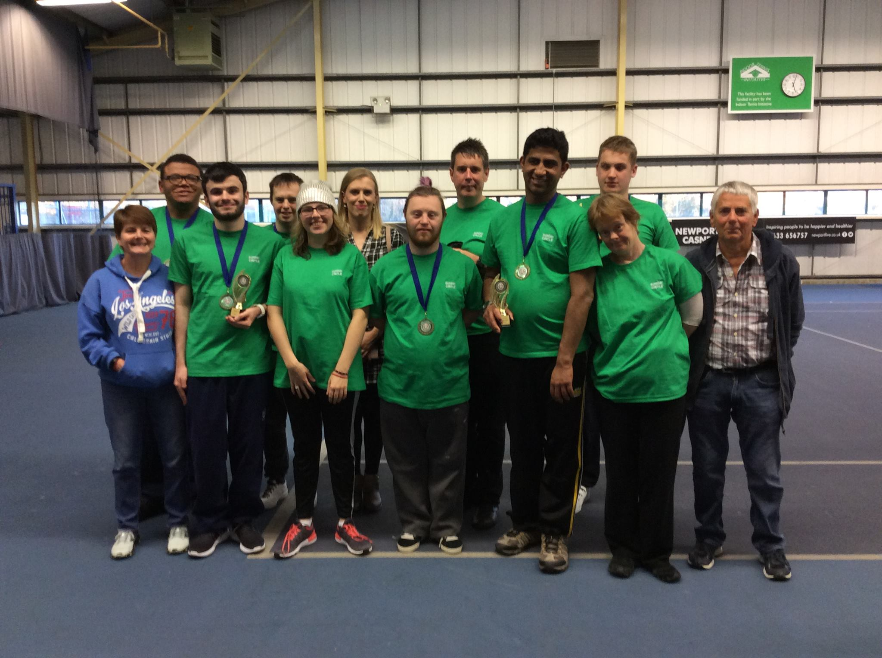

As you may be aware we have a club website [www.sundaycircle.org.uk](http://www.sundaycircle.org.uk). Please keep an eye on the website as it will have all the information you need about club dates, fundraising events as well as publishing the photos we take at club. We also have a dedicated email address for club sundaycirclecardiff@gmail.com