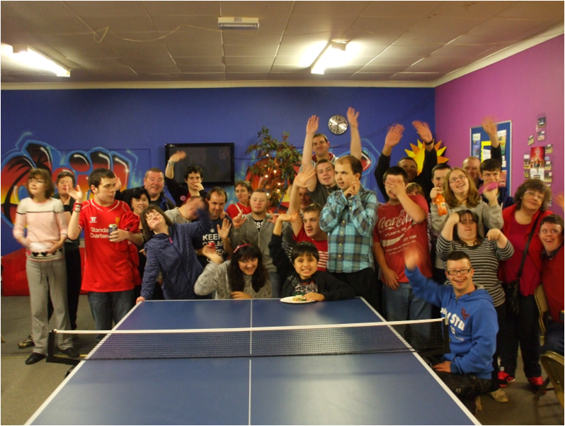  Summer Term 2018 |  | - Sunday Circle

Calling all shoppers
Sunday Circle is now part of easyfundraising – a simple way of helping us raise the much-needed money to keep club running.
easyfundraising is the simplest way to raise money for Sunday Circle.
Shop with any of over 3,300 well-known retailers via the easyfundraising website and a percentage of what you spend is passed to Sunday Circle at no additional cost to you. Retailers include Amazon, M&S, Vodafone, eBay, Tesco, Viking and many more. Please register to support us today – Sunday Circle.

Mention fashion show

Club dates

15th April – 22nd July (half term 27th May – no club)
Bank holiday – 6th May (no club)
Please remember that at club we will be having a fire drill. Cardiff City Council (who owns the building) will be testing the fire alarms on various days/times. When we have a fire drill the club staff will support all our members and any visitors.

Trips and Tickets
In the future all trips with club that require members to purchase tickets will need to be sorted and paid for several weeks in advance. We have had a several trips where members have dropped out at the last minute and this leaves club out of pocket.
You will be advised of the deadline when given information of the events.

Date for your diary

Our annual Christmas Fayre is booked for Saturday 17th November. It will be in Christ the King Parish Hall, Llanishen from 1pm – 4pm.
Pantomime December 2018
We have several tickets for the Pantomime this December. If you would like to go on the list please let Anna know. Tickets will be allocated on a first come first serve basis.

Contact Details
Please remember to let us know when your contact details change, in particular if you move to a new house.

Members in community housing must give us the contact number for the house/staff as well as parent or carer details.
If we do not have current and up to date contact details members may not be able to attend club as in the event of an emergency, we MUST be able to contact the appropriate people.

Thank you to everyone who helped raise over £35 towards the charity BLISS. The money raised goes towards supporting the families of babies who need extra help at the beginning of their lives.
As you may be aware we have a club website www.sundaycircle.org.uk. Please keep an eye on the website as it will have all the information you need about club dates, fundraising events as well as publishing the photos we take at club. We also have a dedicated email address for club sundaycirclecardiff@gmail.com

